**Assignment 1**

**Q. Multi-Branch and Jenkins file**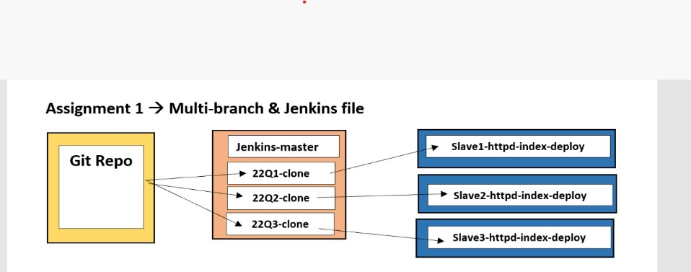

**Step 1.**

* **Launch 4 instance 1- JM, 3-Slaves**
* **Install java-1.8.0-openjdk.x86_64 on each slave i.e slave1, slave2, slave3.**
* **Creating nodes via SSH**

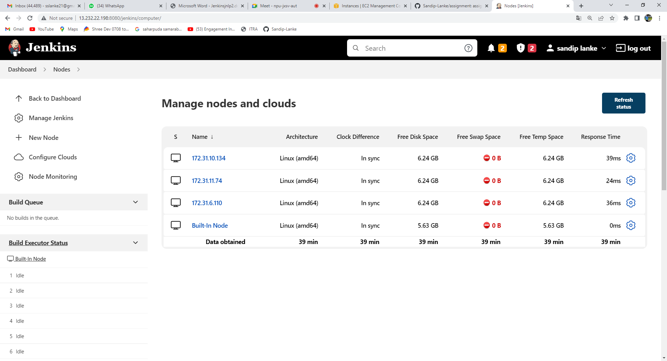

* **Creating root workspace for every slave (/mnt/slave1…..etc)**
* **Giving permission to mnt chmod -R 777 /mnt**

**Step 2.**

* **Creating new dir for this assignment in JM (/mnt/assignment)**
* **Creating index.html file and Jenkinesfile on JM**

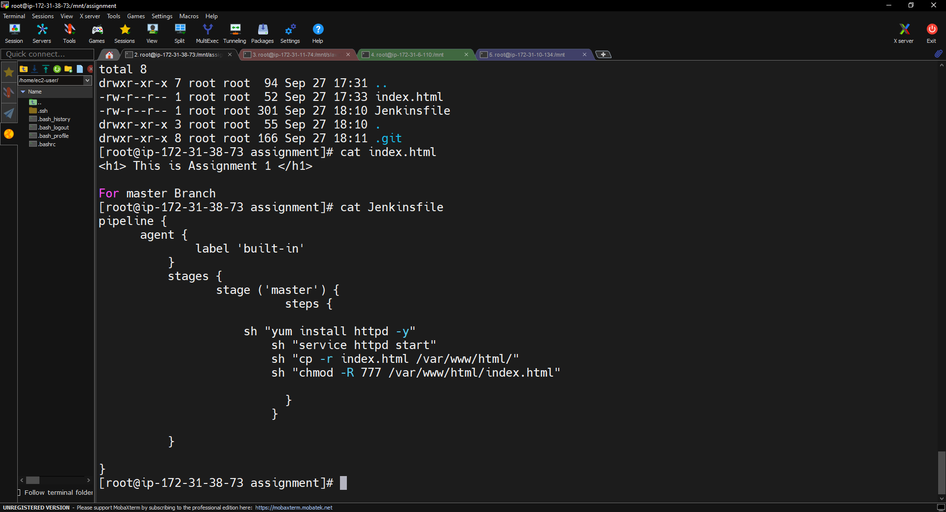

* 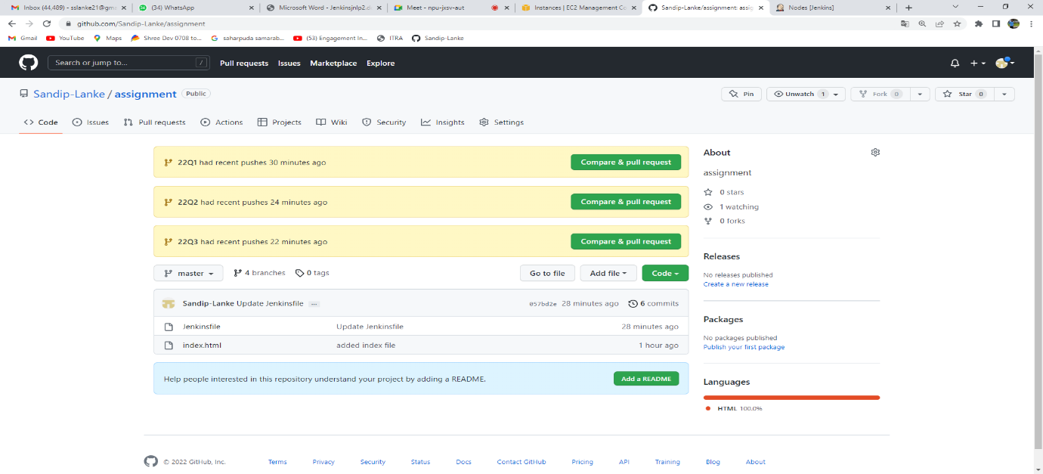**Create one new repository and push all this files in remote repo.**

**Step 3. Creating new Pipeline through multibranch pipeline**

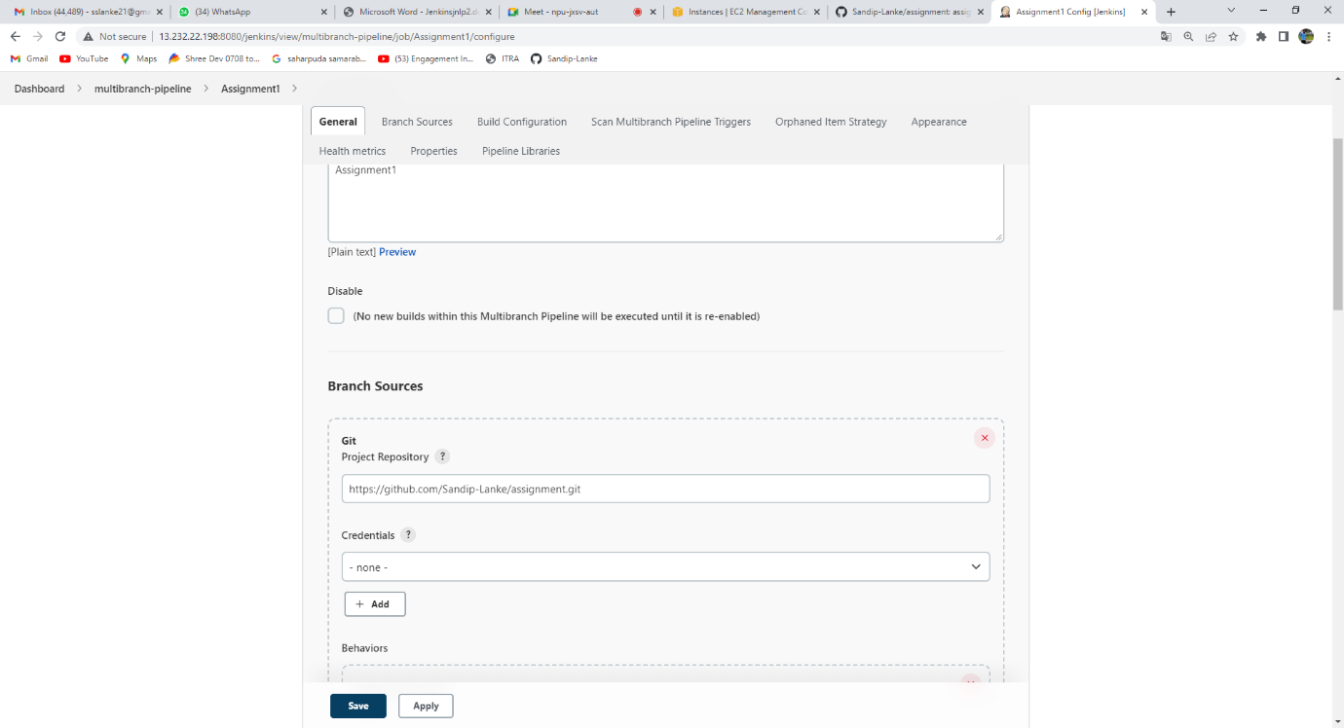

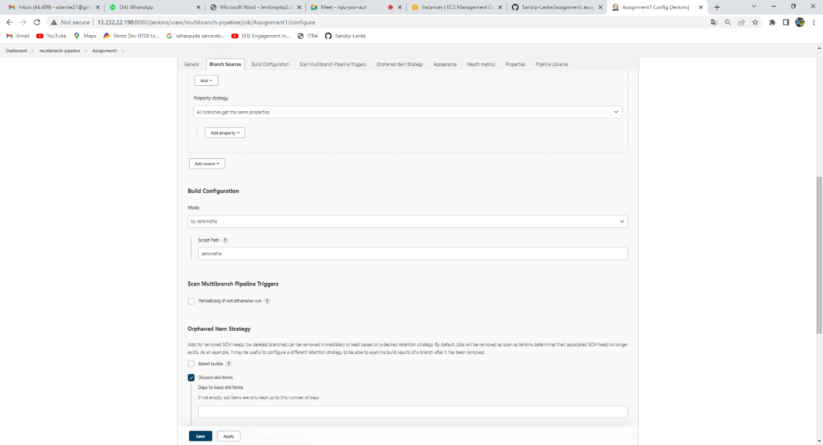

* **Creating new 22Q1 from master and update index file and Jenkins file.**

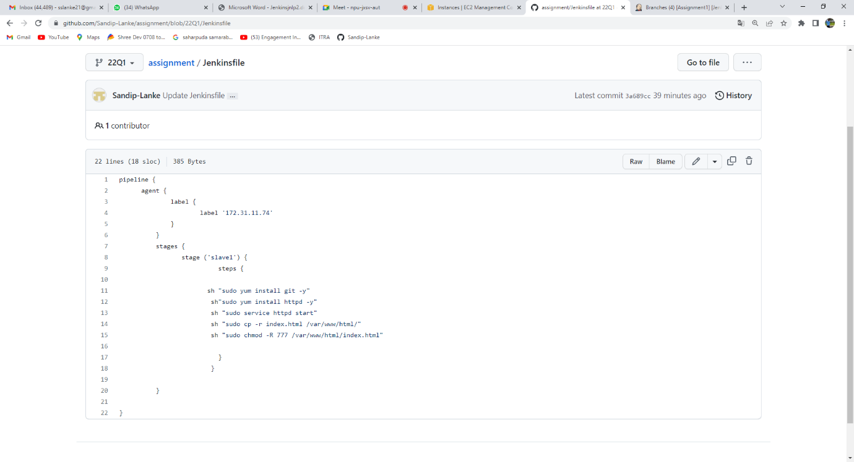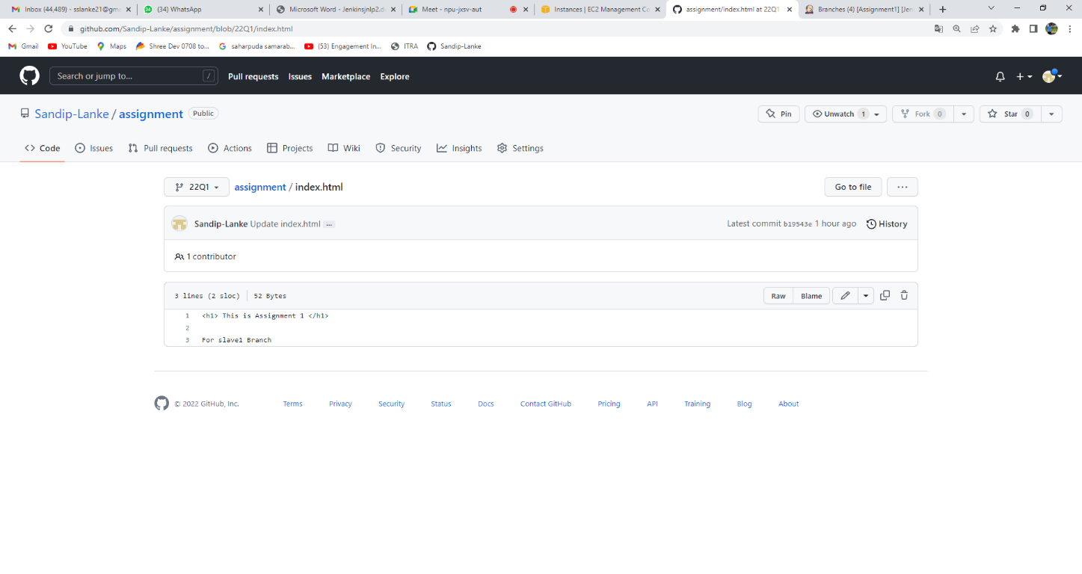**Step 4. Scan Multibranch pipeline**

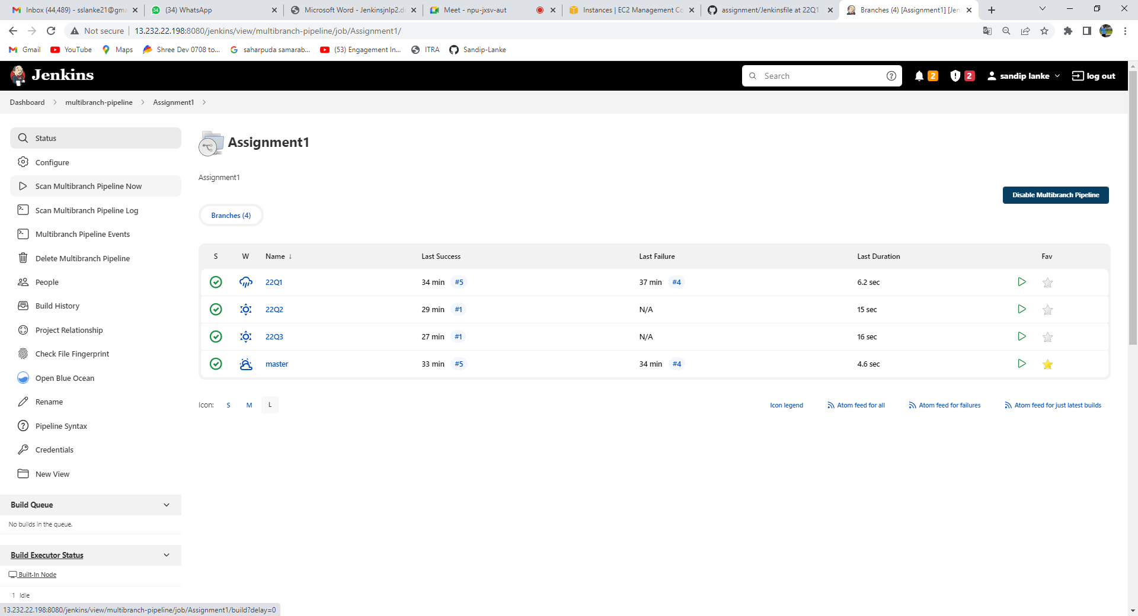



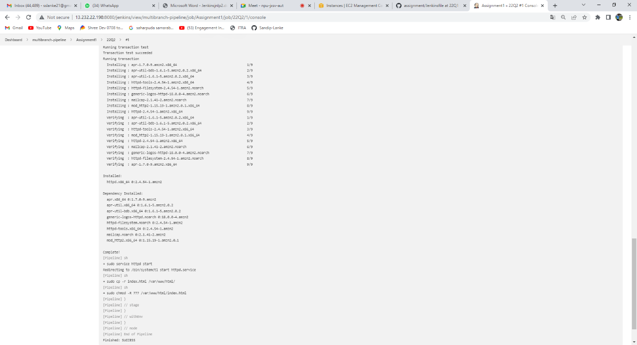

* **step 5. Creating new 22Q2 from 22Q1 and update index file and Jenkins file.**
* **Scan Multibranch pipeline**
* **Creating new 22Q3 from 22Q2 and update index file and Jenkins file.**
* **Scan Multibranch pipeline**

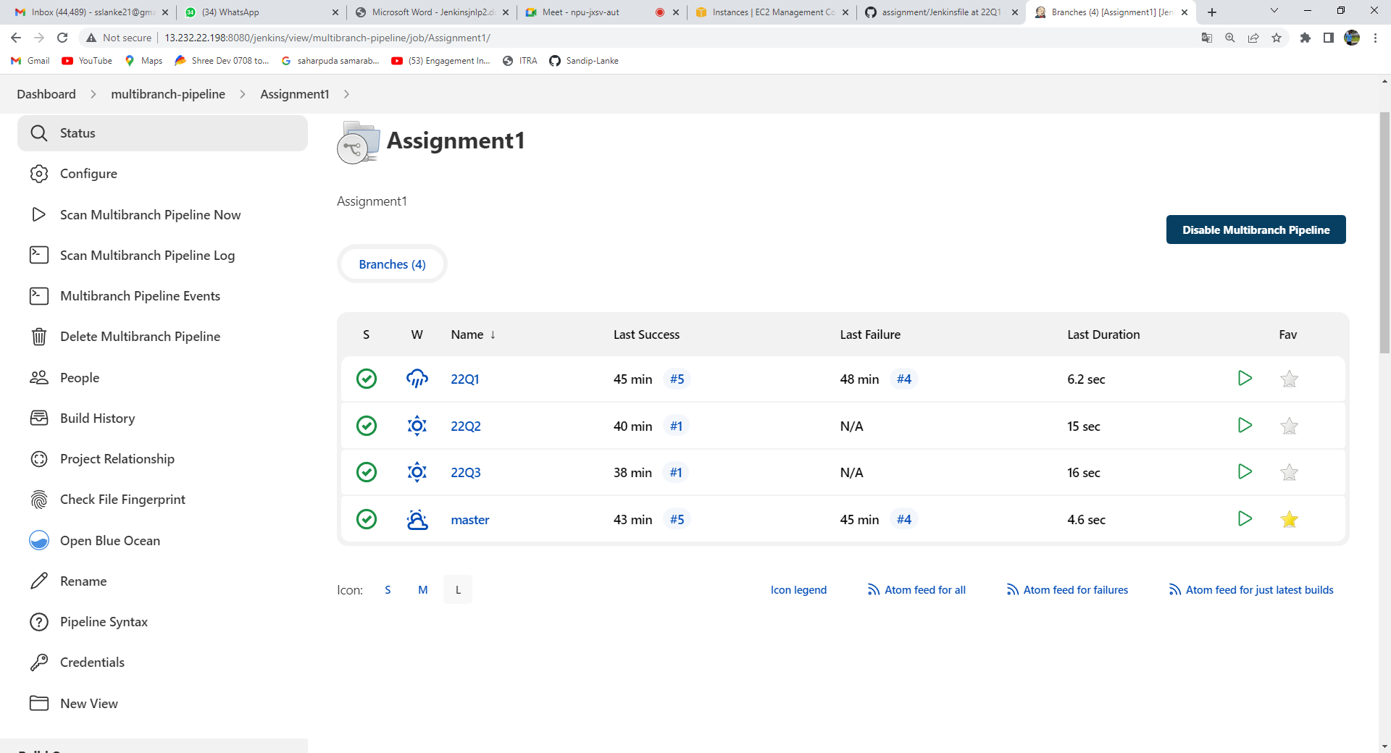

**Output:**

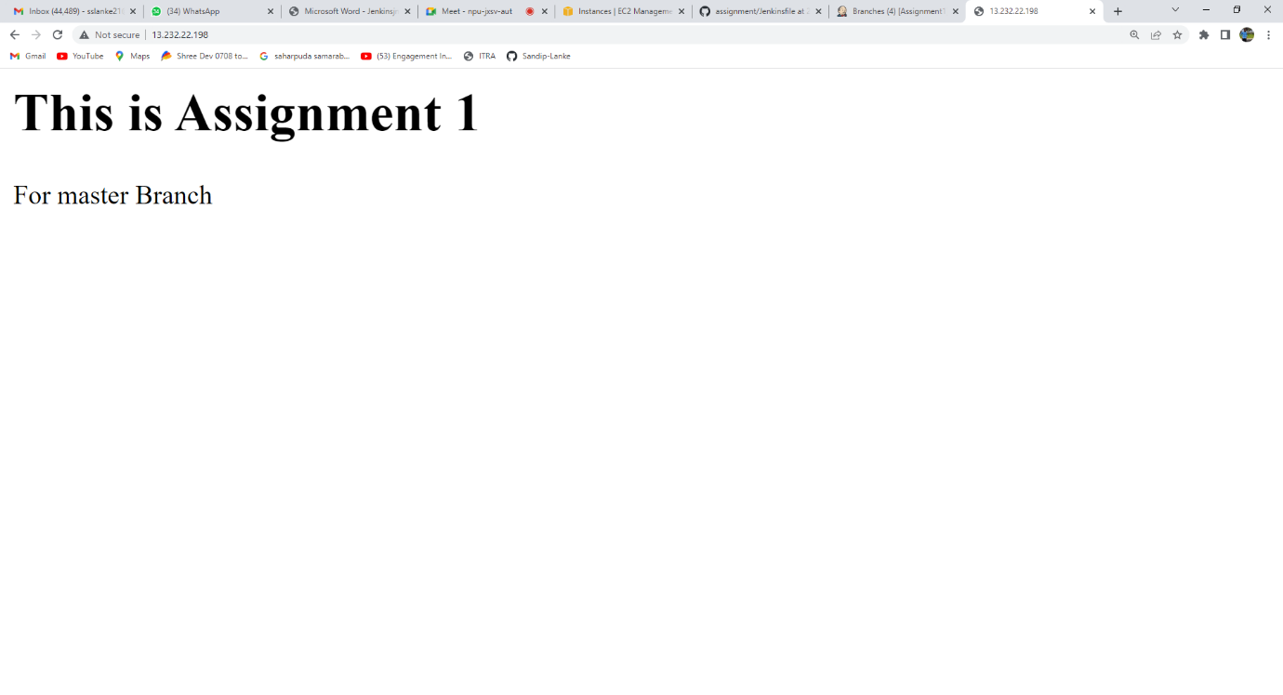**1.For Master**

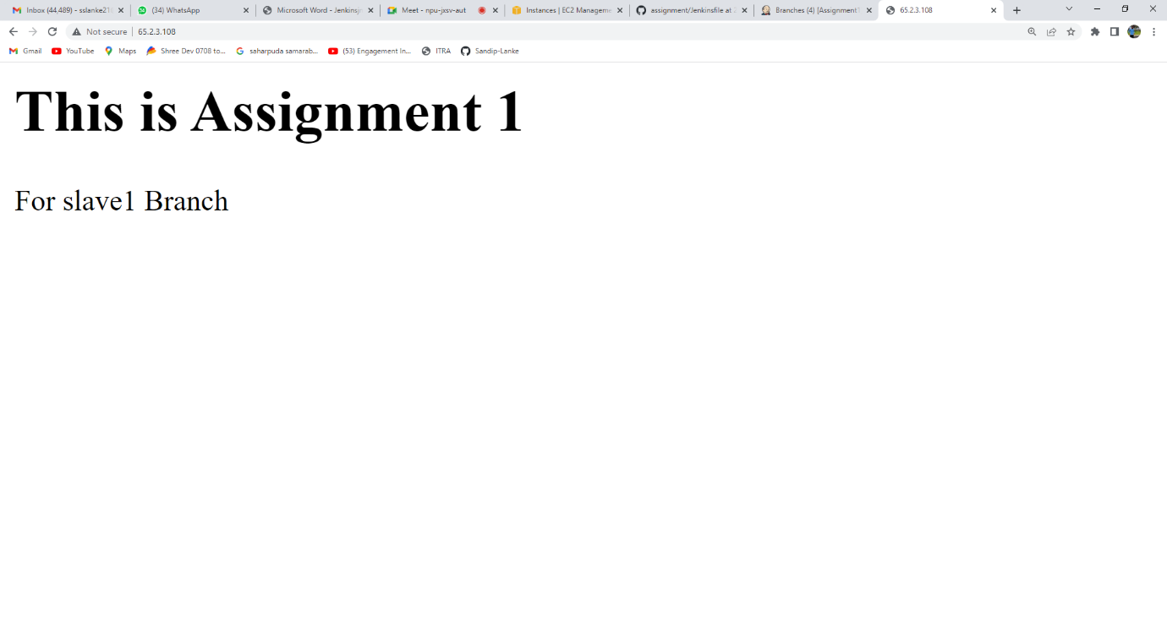**2.For slave 1**

**3.For Slave2**

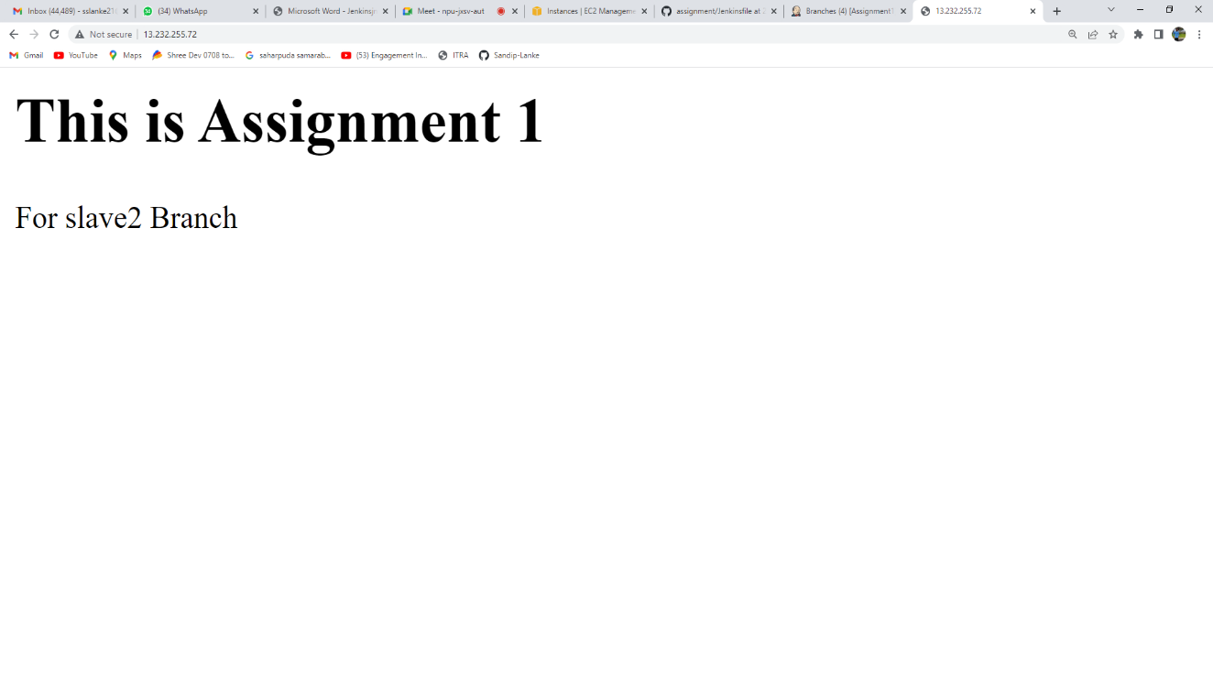

**4.For Slave 3**

